**Power BI**

**Project Report**



**ANALYSIS OF BLINKIT’S SALES PERFORMANCE, CUSTOMER SATISFACTION, AND INVENTORY DISTRIBUTION**

**SUBMITTED TO: Elevate Labs**

**SUBMITTED BY: Charul Manishi**

**CONTENTS**

1. Project description

2. Dataset

Source

Data cleaning

Charts Development

3. Output screenshots (dashboard)

4. Conclusion (Insights from analysis)

1. **PROJECT DESCRIPTION**

This project focuses on leveraging data analytics to enhance Blinkit’s grocery operations by examining sales performance, customer satisfaction, and inventory management. Using an interactive Power BI dashboard, the project provides actionable insights to improve operational efficiency, customer experience, and overall profitability.

**Key Objectives**

1. Sales Performance Analysis:

- Track revenue trends, top-performing products, and regional contributions to identify growth opportunities.

- Highlight underperforming products or regions to develop targeted marketing and sales strategies.

2. Customer Satisfaction Evaluation:

- Analyze customer ratings and feedback to understand key drivers of satisfaction and dissatisfaction.

- Identify improvement areas to enhance service quality and build customer loyalty.

3. Inventory Management Optimization:

- Monitor stock levels, stockout rates, and warehouse efficiency to streamline inventory distribution.

- Reduce holding costs and improve product availability through data-driven stock allocation.

**Tools and Technologies**

The analysis utilizes **Power BI** for data visualization, supplemented by **Excel**. It incorporates KPIs, trend analyses, and interactive visualizations to provide a comprehensive view of operations.

**Outcomes**

- The project identifies actionable insights for optimizing sales strategies, improving customer satisfaction, and managing inventory effectively.

- It provides a foundation for advanced analytics like sales forecasting, customer segmentation, and real-time decision-making, enabling Blinkit to stay competitive in the fast-paced grocery delivery market.

This project serves as a critical step toward implementing a data-driven culture, helping Blinkit scale its operations and deliver superior customer value.**2. DATASET**

**2.1. SOURCE:** Website Kaggle

**Description:** To conduct a comprehensive analysis of Blinkit's sales performance, customer satisfaction, and inventory distribution to identify key insights and opportunities for optimization using various KPIs and visualizations in Power BI.

**KPI's Requirements**

1. Total Sales: The overall revenue generated from all items sold.

2. Average Sales: The average revenue per sale.

3. Number of Items: The total count of different items sold.

4. Average Rating: The average customer rating for items sold

**2.2. DATA CLEANING**

To ensure the accuracy and reliability of the analysis, the following data cleaning steps were performed on Blinkit’s grocery dataset:

1. **Handling Missing Values:**

- Identified missing entries in key columns such as *Item Weight* and *Outlet Size*.

- Imputed missing values:

- Used the median for numerical columns like *Item Weight*.

- Filled missing categorical values, such as *Outlet Size*, based on the most frequent values or related variables (e.g., Outlet Type).

2. **Standardizing Categorical Data:**

- Corrected inconsistencies in text-based data, such as variations in *Item Fat Content* ("Low Fat" vs. "low fat").

- Unified categories for better aggregation and analysis.

3. **Outlier Detection and Treatment:**

- Identified outliers in columns like *Sales* and *Item Visibility* using statistical techniques (e.g., z-scores).

- Treated outliers where necessary to avoid skewed analysis, especially for visibility values.

4. **Data Type Corrections:**

- Ensured all columns had appropriate data types (e.g., converting numerical columns stored as text to numeric).

5. **Removing Duplicates:**

- Checked for and removed duplicate rows to prevent over-representation of data.

6. **Feature Engineering:**

- Derived new columns, such as *Item Age* based on the *Establishment Year*, for additional insights.

These steps ensured a clean, consistent, and ready-to-use dataset, forming a solid foundation for meaningful analysis and visualization.

**2.3. CHARTS DEVELOPMENT**

**1. Total Sales by Fat Content:**

Objective: Analyze the impact of fat content on total sales.

Additional KPI Metrics: Assess how other KPIs (Average Sales, Number of Items, Average Rating) vary with fat content.

Chart Type: Donut Chart.

**2. Total Sales by Item Type:**

Objective: Identify the performance of different item types in terms of total sales.

Additional KPI Metrics: Assess how other KPIs (Average Sales, Number of Items, Average Rating) vary with fat content.

Chart Type: Bar Chart

**3. Fat Content by Outlet for Total Sales:**

Objective: Compare total sales across different outlets segmented by fat content.

Additional KPI Metrics: Assess how other KPIs (Average Sales, Number of Items, Average Rating) vary with fat content.

Chart Type: Stacked Column Chart.

**4. Total Sales by Outlet Establishment:**

Objective: Evaluate how the age or type of outlet establishment influences total sales.

Chart Type: Line Chart.

**5. Sales by Outlet Size:**

Objective: Analyze the correlation between outlet size and total sales.

Chart Type: Donut/ Pie Chart.

**6. Sales by Outlet Location:**

Objective: Assess the geographic distribution of sales across different locations.

Chart Type: Funnel Map.

**7. All Metrics by Outlet Type:**

Objective: Provide a comprehensive view of all key metrics (Total Sales, Average Sales, Number of Items, Average Rating) broken down by different outlet types.

Chart Type: Matrix Card.

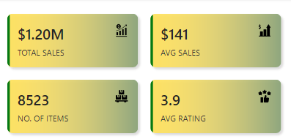

1. **OUTPUT SCREENSHOT (DASHBOARD)**

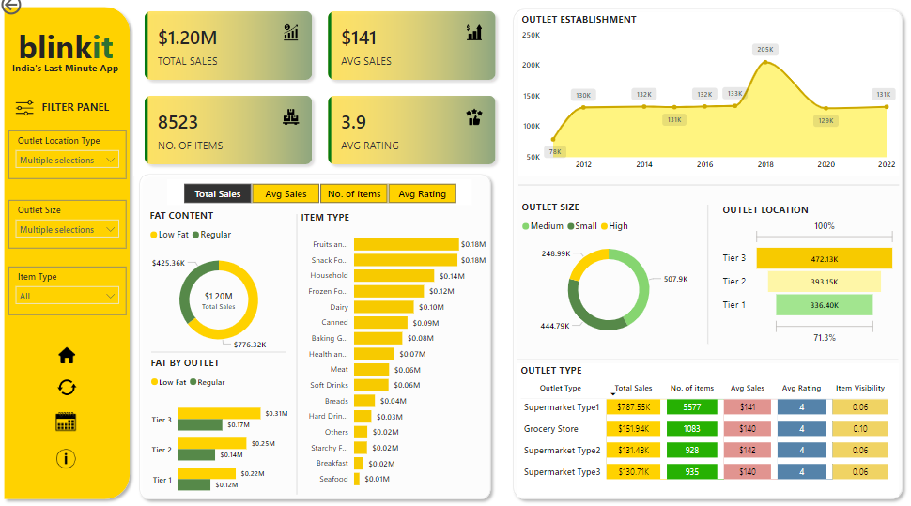

1. **CONCLUSION: INSIGHTS FROM ANALYSIS**

**1. Sales Performance**

- Top Product Categories: High sales are linked to certain categories like "Fruits and Vegetables" and "Frozen Foods," reflecting customer preferences.

- Outlet Contribution: Supermarkets in Tier 1 and Tier 2 locations show higher sales, indicating stronger market demand in these areas.

- Seasonal Trends and Item Visibility**:** Products with higher visibility have consistently better sales, suggesting effective marketing placement significantly influences purchasing behavior.

**2. Customer Satisfaction (Ratings)**

- Consistently High Ratings: Items with low visibility but high sales ratings highlight potential best-sellers with untapped promotional opportunities.

- Low-rated Products: Specific products or locations with lower ratings can be targeted for quality or service improvements.

**3. Inventory Distribution**

- Stock Balancing: The relationship between high sales and outlet size can help optimize stock allocations to prevent shortages or overstocking in Tier 1 and Tier 3 locations.

- Outlet Size and Type: Medium-sized outlets show higher sales efficiency, offering a model for scaling small-sized outlets.

These insights can help Blinkit focus on improving marketing strategies, refining inventory management practices, and enhancing customer satisfaction for better profitability and service delivery.